Assignment 10 :

- Write a procedure that computes the perimeter and the area of a rectangle. Define your own values for the length and width. (Assuming that L and W are the length and width of the rectangle, Perimeter = 2*(L+W) and Area = L*W.
- DROP PROCEDURE IF EXISTS calc_rectangle;

- DELIMITER $$

- CREATE PROCEDURE calc_rectangle(IN L DOUBLE, IN W DOUBLE, OUT perimeter DOUBLE, OUT area DOUBLE)
- BEGIN
- SET perimeter = 2 * (L + W);
- SET area = L * W;
- END;

- $$

- DELIMITER ;

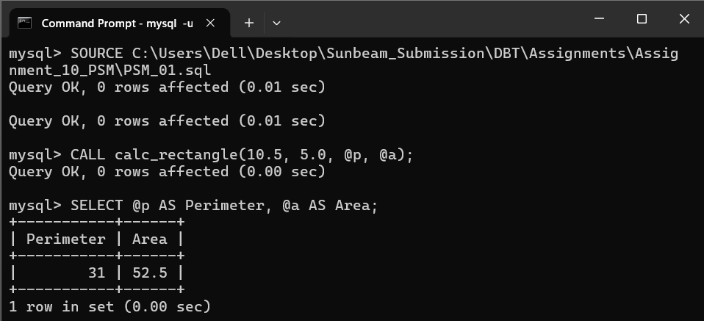

2. Write a procedure that declares an integer variable called num, assigns a value to it, computes and inserts into the temp table the value of the variable itself, its square, and its cube.

DROP PROCEDURE IF EXISTS insert_num_powers;

DELIMITER $$

CREATE PROCEDURE insert_num_powers(IN num INT)
BEGIN
DECLARE v_square INT;
DECLARE v_cube INT;

SET v_square = num * num;
SET v_cube = num * num * num;

INSERT INTO temp (val, square, `cube`)
VALUES (num, v_square, v_cube);

END;

$$

DELIMITER ;

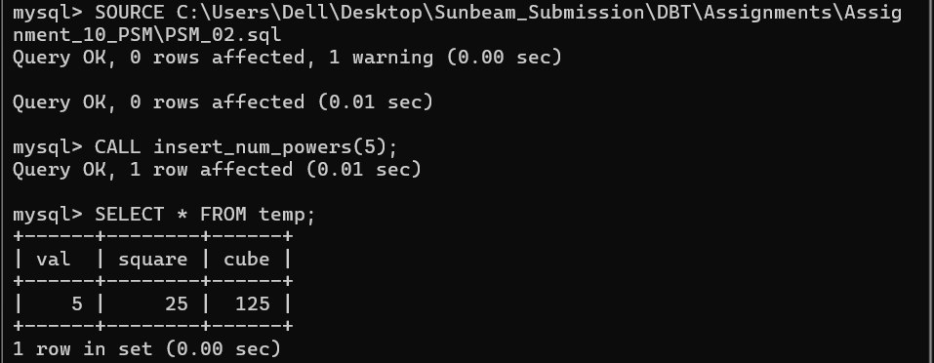

3. Create a procedure to Convert a temperature in Fahrenheit (F) to its equivalent in Celsius (C) and vice versa. The required formulae are C= (F-32) *5/9 F= 9/5*C + 32
DROP PROCEDURE IF EXISTS convert_temperature;

DELIMITER $$
CREATE PROCEDURE convert_temperature(
IN temp_val DOUBLE,
IN unit CHAR(1),
OUT converted_temp DOUBLE
)
BEGIN
IF UPPER(unit) = 'F' THEN
SET converted_temp = (temp_val - 32) * 5/9;
ELSEIF UPPER(unit) = 'C' THEN
SET converted_temp = (9/5) * temp_val + 32;
ELSE
SET converted_temp = NULL;
END IF;

END;
$$
DELIMITER ;

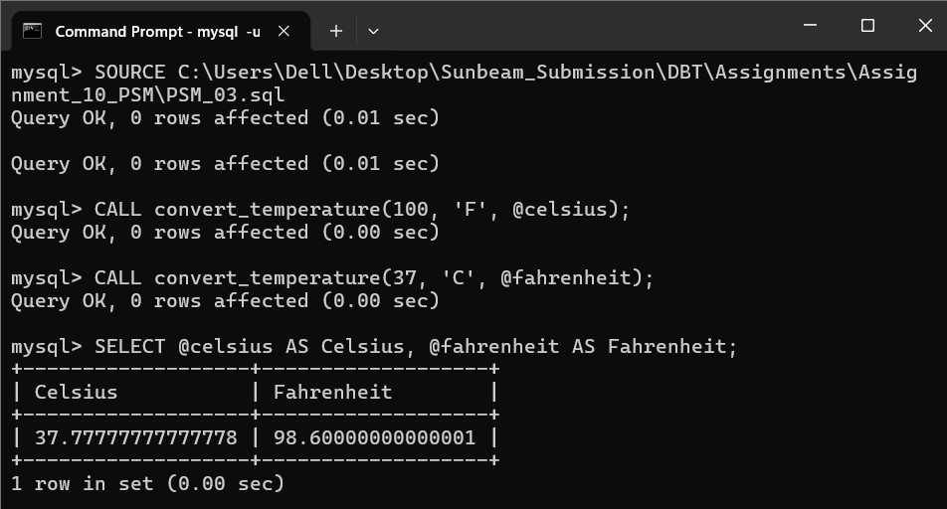
4. Create a procedure to Convert a number of inches into yards, feet, and inches. For example, 124 inches equals 3 yards, 1 foot, and 4 inches.
DROP PROCEDURE IF EXISTS convert_inches;

DELIMITER $$

CREATE PROCEDURE convert_inches(
IN total_inches INT,
OUT yards INT,
OUT feet INT,
OUT remaining_inches INT
)
BEGIN
SET yards = total_inches DIV 36;
SET feet = (total_inches % 36) DIV 12;
SET remaining_inches = total_inches % 12;

END;

$$

DELIMITER ;

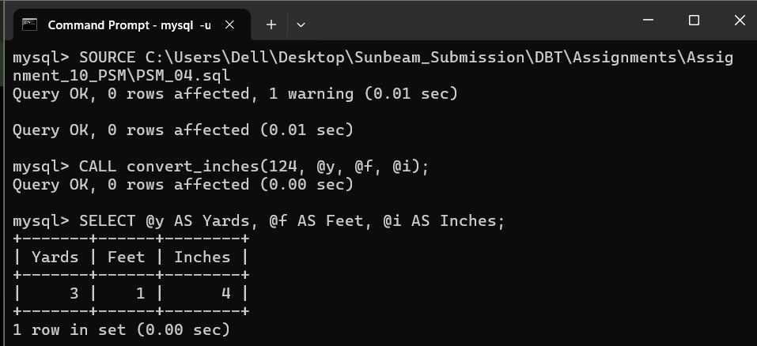
5. Create a procedure to read two real numbers and tell whether the product of the two numbers is equal to or greater than 100.
DROP PROCEDURE IF EXISTS check_product;

DELIMITER $$
CREATE PROCEDURE check_product(
IN num1 DOUBLE,
IN num1 DOUBLE,
OUT result VARCHAR(100)
)
BEGIN
DECLARE prod DOUBLE;
SET prod = num1 * num2;

IF prod >= 100 THEN
SET result = CONCAT('Product (', prod, ') is equal to or greater than 100');
ELSE
SET result = CONCAT('Product (', prod, ') is less than 100');
END IF;

END;
$$
DELIMITER ;



